**Health Supervision System**

The Health Supervision System is a web application that provides personalized health recommendations based on user data and allows user to track and access their health history. The system is developed using React JavaScript library for the frontend, the Java enterprise edition (J2EE) for the backend, and MYSQL for the data Storage.

This README file provides an overview of the system’s and other relevant information.

**The system have following features:**

1.**User Registration and Login** : Users can create an account and securely log in to access system’s functionalities.

2.**Health Data Input** : Users can input various Health related data, such as weight, age, blood pressure, blood sugar level and different health specific parameters.

3.**Health History Tracking** : The system maintains health history of user to track their progress and other health relevant information.

4.**Recommentation** **Generation** : Based on the User’s input health data, the system generates personalized recommendations to exercise, diet and other aspects of health to live a healthier life.

5.**Dashboard**: User can view there personalized health recommendation and can access their health history .

Overall, this system helps and guide user in making informed decisions about their healthcare by providing personalized recommendations and to track their progress by accessing health history.

Usage along with the Screenshots :

**1.Home Page**



**2.Registration**

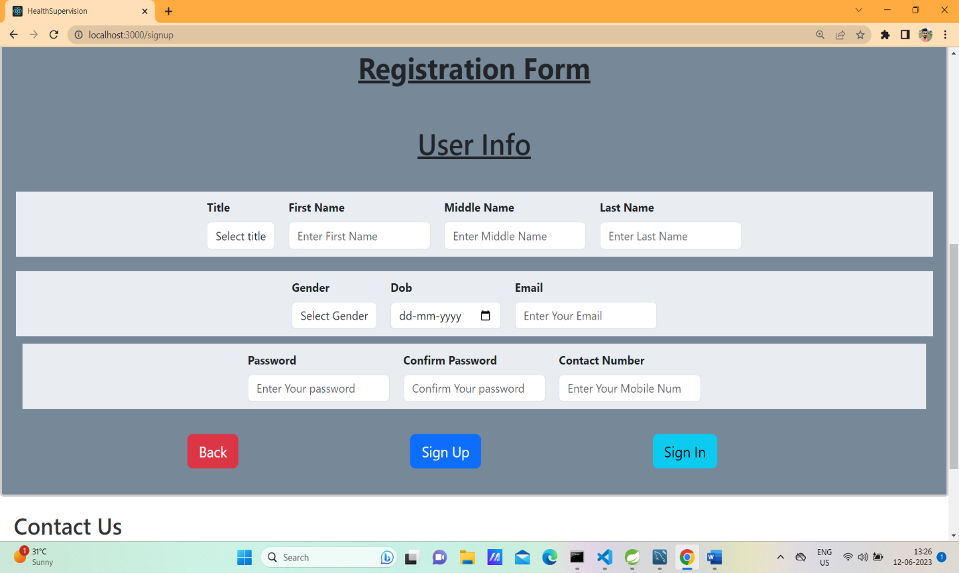

**3.Login**

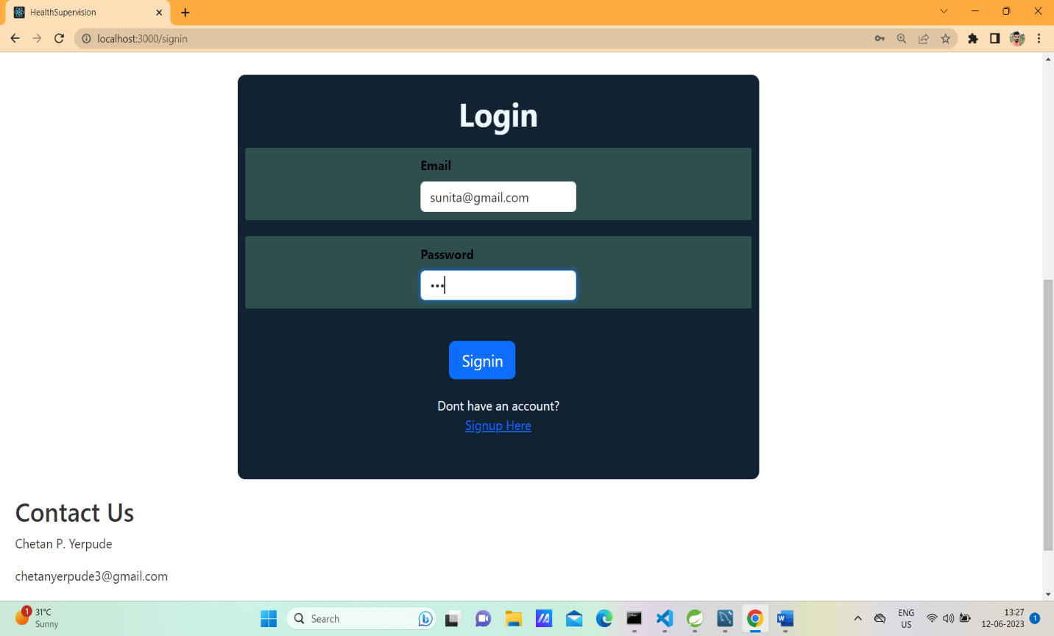Top of Form

**4.Dashboard**

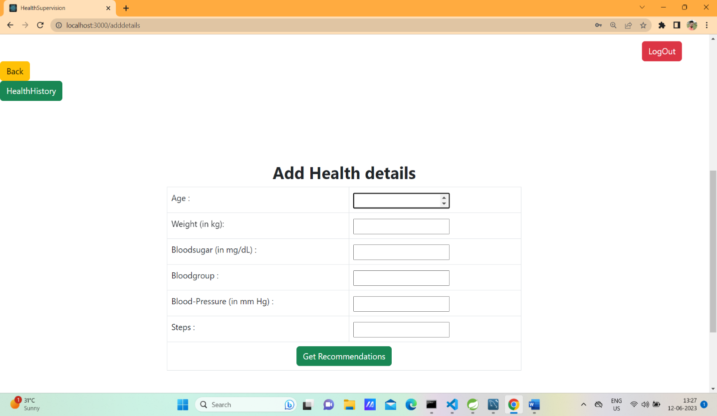

**5.Health History**

